

Modeling and Verifying Student Grade Web Application System

INSE- 6250 Project Report

Submitted To:
Dr. Jamal Benthar

Submitted By:
Mayank Kumar (26885624)
Dhruv Ohri (27149220)
Table of Contents
Abstract 3
1.0 Introduction 4
1.1 Project Approach 4
1.2 Objectives 4
2.0 Model Checking 5
2.1 Purpose of Model Checking 6
2.2 Steps of Model Checking 7
2.3 System Model Representation 7
2.4 Specification Representation 8
3.0 Implementation Model 9
3.1 Model Description 11
3.2 Requirement Specifications or Properties 12
4.0 Model Checking with NuSMV 15
4.1 Verification of Requirement Specification or Properties 15
4.2 Result 16
5.0 Conclusion 16
6.0 Future Work 16
7.0 References 17
8.0 Appendix 17
8.1 NuSMV Code 17
8.2 Counter Examples 21

Abstract

In recent time, we observe an increasing number of Web applications or online portals which caters to university/college students. However, verification of the correctness of these fast growing Web applications’ designs has been done manually in most of the cases. As these web applications provide various student features and they are used by numerous students, the quality and correctness of these applications is very important.

This paper proposes a model checking approach for web application of WGVS (Web Grade View System). Kripke structure is constructed to model the system, the mathematical model of which is represented by a Finite State Machine (FSM) from student’s perspective. In this work, the entire Web application of grading system has been modeled by using page, build and link atomic propositions and the related transitions. In order to perform the model checking, first we selected some properties from our model. Then, by using the CTL formal language, we formalize basic criteria to establish correctness of the application. CTL specifications are added and translated as source code for NuSMV Interactive- model checker tool. Finally, the NuSMV tool performs automatic verification and locates errors in application design in the form of counter examples when our model does not satisfy any property

1.0 Introduction
Student Grading systems has been used quite a frequently now a days to acquire the student information and view the grades. The accuracy of these web applications is of utmost importance as the failure often causes student dissatisfaction. Therefore the verification of these web portals is vital in order to ensure the quality of the service features. Specification of these online applications takes considerable time to be decided so as to design of web pages in user friendly and appealing way while navigating through the application.

A formal method like Model Checking has becoming popular as it verifies the state transition system and executes an automated verification of a system model with respect to its specification. Different from testing which needs user communication, model checking is a model-based, property-verification, automatic method in order to develop high assurance systems. The other advantage of model checking is that there are several efficient implementation tools such as NuSMV and SPIN, which had successfully verified large real-world systems.

In this paper, we concentrate on verification of set of properties using the model of Web application for grading system using NuSMV (New Symbolic Model Verifier (NuSMV), a tool for checking finite state systems against specifications expressed as CTL formulas.

1.1 Project Approach
- The entire web applications can be modeled by web page transitions to give a clear understanding of the process model
- General assertions for verifying Web applications are proposed which are defined by both LTL and CTL formulas.

1.2 Objectives
- Improving the quality of student grade online application by verifying the quality attributes using model checking technique
- To explain how the model checking technique is used to verify the properties of a model
- To find the specifications which are not satisfied by the model of the student grade online portal so as to improvise the designing of model in terms of web page states or related transitions

2.0 Model Checking
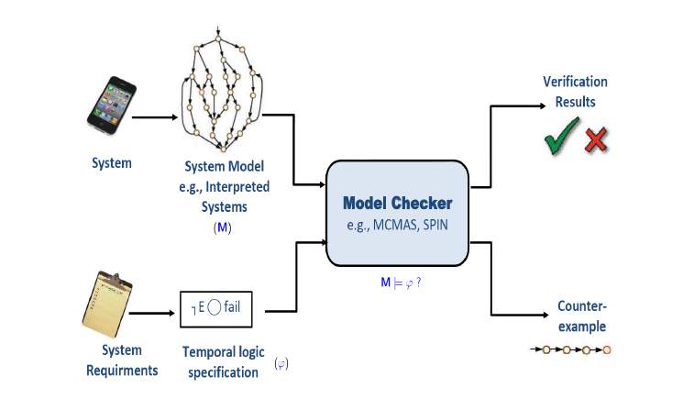
Figure 1: Non-Probablistic Model Checking
Model checking is a formal method to verify, if a software system or model meets the properties asserted by users or not. A formal system model describes the behavior of the system based on user requirements. Model checking discovers the properties of the system stated by the user and checks that those are valid or not on the model. Generally the properties, which the system has to satisfy, are defined in a formal way using temporal logic formulas and the model is defined as finite state transition systems. Model checkers build a finite state system and exhaustively explore the reachable state where the properties being checked are being violated. Both the model of the system and the specification can be modeled by the formal description language which acts as input to model checker and formulated as a task in logic, namely to check whether a given structure satisfies a given logical formula. If the formula fails, a counterexample is generated in the form of a sequence of states from its initial state to a state where the violation occurs. [1]. The finite system can be represented by a Kripke structure as defined in [4]
De_nition 1. A Kripke structure (or state transition system) M is a
quadruple M = hS; S0;R;Li consisting of
1. a _nite set of states S;
2. a set of initial states S0 _ S;
3. a total transition relation R _ S _ S; that is, for every state s 2 S there
exists a state s0 2 S such that (s; s0) 2 R;
4. a set AP of atomic propositions (Boolean functions over S) and a labeling
function L : S ! 2AP that labels each state with the set of atomic proposi-
tions that hold in that state.
A path _ in M from a state s0 is

2.1 Purpose of Model Checking
- Model Checking ones do not need a preliminary interaction with the user for selecting inputs as test case, hence it could be used in design phase allowing to locate mistakes or malfunctions. [2]
- It is useful technique as it allows us to check the rightness of yet to be developed system. System modeling is the process of developing the system model and all the essential system properties in a formal language and after that verifying these properties over the developed system model to ensure that the system is satisfying all the desired properties. As it is done before actual implementation of the system therefore it helps us to recognize many undetectable errors that could occur in system and thus reduces the efforts related to testing. The system model can then be modified or changed to improve and mitigate these errors until a fully flawless requirement satisfying model is obtained. This model can further be used during the phase of implantation.[5]
- Model checking is a useful technique that traverses the different possible states of the system in a brute force manner. In other words, we can say that in model checking, all the possible scenarios of the system are examined in a systematic manner.[2]
- In model based specification, a system is specified in terms of state model. This model is constructed using the mathematical constructs such as sets and sequences. Different operations are defined by doing the modifications to these system’s states. The model is modified or changed to mitigate the errors until a model is achieved which is free from all the ambiguities and errors.[2]
- Model checking is fully automated. No expert is required in order to check whether a given finite state model conforms to a given set of system specifications. Model checking also works with partial specifications (properties can be checked individually) which are often troublesome for techniques based on theorem proving.
- Model checking is based on theory of graph algorithms, data structure and logic and can be easily integrated in existing development cycles.

2.2 Steps of Model Checking
- a model specification language- a formal notation for encoding the system to be verified as a finite-state transition system, i.e., the model M
- a property specification language φ based on temporal logic
- a verification procedure - an intelligent exhaustive search of the model state space that determines whether the specification is satisfied or not (If M ╞ φ). In the latter case, the procedure provides a counterexample exhibiting the violation of the specification. [4]
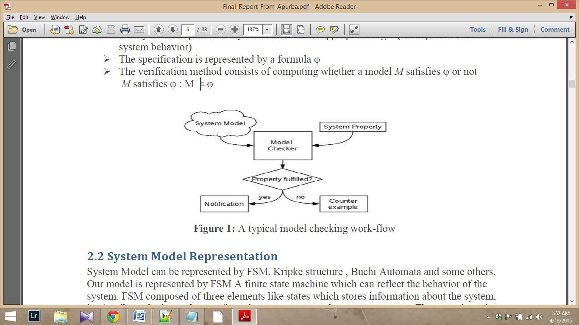
Figure 2: Work-flow of model checking

2.3 System Model Representation
System Model can be represented by FSM, Kripke structure, Buchi Automata and some others. Our model is represented by FSM which reflects the behavior of the system. FSM composed of three elements like states which stores information about the system, i.e. it reflects the input changes from the system start to the present moment. The second one is transitions which indicates a state change and is described by a condition that would need to be fulfilled to enable the transition. The third one is Actions which is a description of an activity that is to be performed at a given moment. [1]

2.4 Specification Representation
The properties of our model are written using temporal logic which provides a formal system for describing and reasoning about how the truth values change over time. It is appropriate for describing the time varying behavior of systems. The properties to be checked can be written in propositional LTL and CTL format. Now we introduce the syntax of these two languages.
LTL (Linear Temporal Logic)
Linear temporal logic is an infinite sequence of states where each point in time has a unique successor, based on a linear-time perspective. Linear temporal property is a temporal logic formula that describes a set of infinite sequences for which it is true. The syntax of LTL formulas can be defined in [1] and are as follows
Φ ::= p | דΦ | Φ ∨ Φ | XΦ | Φ U Φ where
- p is a formula
- p is a formula ,if Φ is a formula, then דΦ is a formula
- If Φ and Ψ are formulas, then Φ ∨ Ψ is a formula
- If Φ is a formula then X Φ is a formula
- If Φ is a formula, then XΦ is a formula and if Φ and Ψ are formulas, then Φ U Ψ is a formula
- Anything else is not a formula
Elements:
- A set of atomic propositions: AP (p ∈ AP) and two constants: True and False
- Boolean Operators: ∨, ד
- Additional Operators: ^, =>, ⬄
- Temporal operators X, U (Next and Until)
CTL (Computational Tree Logic)
Model checking is based on temporal logic. CTL (Computation Tree Logic) is branching-time logic, meaning that its model of time is a tree-like structure in which the future is not determined. It is based on propositional logic with a discrete notion of time and only future modalities. In CTL temporal operators quantify over the paths that are possible from a given state (branching time). In CTL, each basic temporal operator must be immediately preceded by a path quantifier (i.e., either A or E). The verified properties on model can be formulized by CTL. The syntax of CTL formulas can be defined by Backus-Naur form:
φ ::= T | ⊥ | p | ￢φ |φ ∧ϕ |φ ∨ϕ | φ →ϕ | AXφ | EXφ |AFφ |EFφ | AGφ | EGφ |A[φ U ϕ] | E[φ U ϕ] , where
- T and ⊥ is true and false, the atomic proposition p is a CTL formula.
- If φ ,ϕ is CTL formula, then ￢φ,φ ∧ϕ ,φ ∨ϕ ,φ→ϕ ,AXφ ,EXφ,AFφ ,EFφ ,AGφ ,EGφ ,A[φ U ϕ ] and E[φ U ϕ ] is CTL formulas. [1]
Here, CTL temporal connectives are a pair of symbols. The first of the pair is one of A or E. A means ‘along All paths from the current state’ and E means ‘There Exists one path from the current state’. The second one of the pair is the temporal operator X, F, G, or U, meaning ‘neXt state’, ‘some Future state’, ‘all future states (Globally)’, and ‘Until’. For example, EFq denotes there is a reachable state satisfying q. AF￢q denotes along all paths, q is violated sometime in the future. If AF￢q is violated, then denotes there existing an infinite path where q always holds. This path is called a counterexample of AF￢q.

3.0 Implementation Model
In order to reason about the correctness of a system, one needs to specify the properties that the system should satisfy, i.e., the intended behavior of the system. Once we have such a specification we need to construct a formal model for the system. Such a model should capture the basic properties that must be considered in order to verify the behavioral specification (the so called atomic propositions). Furthermore, to make the verification simpler, the model should abstract away all the details that have no effect on the correctness with respect to the specification. [4]
In this paper, we designed the Kripke structure to modeling the implementation of Web applications. Actually, the Kripke structure is a type of state transition graph, nodes expressing the reachable states of the system and edges expressing the state transitions. A Kripke structure consists of a finite set of states, a set of state transitions (i.e., a relation over the states), and a labeling function which assigns to each state the set of atomic propositions that are true in this state. In such a model, at any point in time the system is in one of the possible states, and the transition relation describes how the system moves from a state to another over one time step. [4]
Definition: The Web application is modeled by a Kripke structure K, where
- S is a set of Web pages or components.
- S0 is the set of initial state; we assume the homepage in S0 is used as the only initial state where the request can be sent.
- AP is a set of atomic propositions includes Web pages, components and request properties.
In this project we focus on the interactions between the online grade application and its users, i.e. without considering the internal behavior of the applications. Users send requests to the Web application, and the Web application receives the requests and generates corresponding Web pages as responses. For page-page Name/component name specifying the name of the corresponding Web page or component. Request properties specify whether requests are enabled. For a request q, link-q denotes a hyperlink from a Web page to Webpage q; call-q denotes Web pages can call software components by sending requests by hyperlink attributes or action attributes of Forms (a submit action or a hyperlink to a software component q); build-q denotes a response from the Web server.

3.1 Model Description
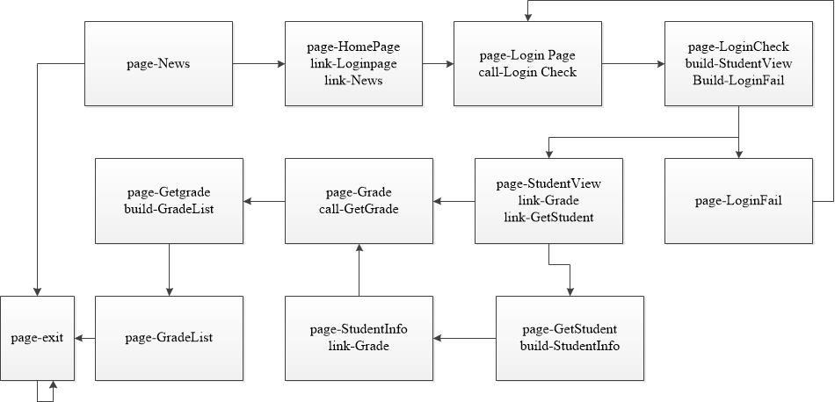
Figure 3: The Kripke Structure for WSGS
A typical Web application similar to the Web Student Grading System (WSGS) is modeled and visually represented (MS VISIO) using Kripke structure in Figure 3 where page-, link-, call- and build- are all atomic propositions of the Web application model. In HomePage, the only initial state where the request can be sent, a student can review the news without login. User can exit the portal after reviewing the page-News. But if he wants to view his grades, he must fill in his/her login information, and clicks the submit button to login the Web system. Upon this clicking, the HomePage will call the component LoginCheck to check whether the login information is right or not. The page StudentView is shown if checking is valid or LoginFail otherwise. If Login is unsuccessful, there would be transition from page- LoginFail to page-LoginPage. In StudentView page, the student can view his grades and personal information. In the page Grade, he can enter the condition for viewing grade. Once the request is submitted, the component GetGrade will build dynamically a GradeList page that satisfying the condition. User can exit at this point after reviewing the page-GradeList details. As the same, when the student want to view his/her personal information, the component GetStudent will build a dynamic page StudentInfo about his/her personal information. In the page StudentInfo, the students can also navigate to the page Grade to view his grade.
In this paper, CTL is used as language to define properties to be verified and SMV as tool for automatic counterexamples generation. SMV supplies a language for depicting the models and it verifies the validity of CTL/LTL formulas properties on those models.

3.2 Requirement Specifications or Properties
We categorized the properties or specifications to be verified into REACHABILITY, LIVENSS and SAFETY and represented all Web pages and components as page- and the relationships between Web pages and components as link-q, call-q and build-q.
- Reachability Property (State Coverage): All states of the Web application model must be covered at least once by the generation of system properties. Reachability property for a web page page-s is defined in CTL formula with EF operator: EF page-s. All page Reachability properties of our E-shopping web application are listed in Table 1.
Table 1
No | State | Property
P1 | HomePage | AG (page-HomePage -> AX page-LoginPage)
P2 | News | EF page-News
P3 | LoginPage | EF page-LoginPage
P4 | LoginFail | EF page-LoginPage;
P5 | LoginCheck | AG (page-LoginCheck -> AX page-StudentView)
P6 | StudentView | AG (page-StudentView -> AX page-Grade)
P7 | Grade | EF page-Grade
P8 | GetGrade | EF page-GetGrade
P9 | GradeList | EF page-GradeList
P10 | GetStudent | EF page-GetStudent
P11 | StudentInfo | EF page-StudentInfo

- Liveness property (Transition Coverage): All transitions of the Web application model must be covered at least once by the generation of system properties. These properties denotes the liveness of the model, i.e., the Web application implements all the legal navigations. According to the implement model K of Web applications, the transitions of state s and s’ are (s, link, s’), (s, call, s’), (s, build, s’). The method of generating liveness properties is shown as follows:
- For each transition in the form of (s, link, s’), where both s and s’ are Web page states, the corresponding property can be represented as: AG (page-s → (link-s’ ∧ EX page-s’))
- For each transition in the form of (s, call, s’), where s is a Web page state and s’ is a component state, the corresponding property can be represented as: AG (page-s →(call-s’ ∧ EX page-s’))
- For each transition in the form of (s, build, s’) , where s is a component state and s’ is a Web page state, the corresponding property can be represented as: AG (build-s’ → EX page-s’). All liveness properties of our web application are listed in Table 2 below
P12 | (HomePage, link,News) | AG EF(page-HomePage -> (link-News & EX page-News))
P13 | (HomePage, link,LoginPage) | AG EF(page-HomePage -> (link-LoginPage & EX page-LoginPage))
P14 | (LoginPage,call,LoginCheck) | AG EF(page-LoginPage ->(call-LoginCheck & EX page-LoginCheck))
P15 | (LoginCheck,build, Student-View) | AG EF(build-StudentView -> EX page-StudentView)
P16 | (LoginCheck,build, LoginFail) | AG EF(build-LoginFail -> EX page-LoginFail)
P17 | (StudentView,link, Grade) | AG EF(page-StudentView -> (link-Grade & EX page-Grade))
P18 | (StudentView,call, GetStudent) | AG EF(page-StudentView ->(call-GetStudent & EX page-GetStudent))
P19 | (Grade, call, Get-Grade) | AG EF(page-Grade ->(call-GetGrade & EX page-GetGrade))
P20 | (GetStudent,build, StudentInfo) | AG EF(build-StudentInfo -> EX page-StudentInfo)
P21 | (StudentInfo, link,Grade) | AG EF(page-StudentInfo ->(link-Grade & EX page-Grade))
P22 | (GetGrade, build,GradeList) | AG EF(build-GradeList -> EX page-GradeList)
P23 | (StudentInfo,link,Gradelist) | AG(page-StudentInfo -> (link-Grade & EX page-GradeList))
P24 | (StudentView,link,Gradelist) | AG(page-StudentView -> (link-Grade & EX page-GradeList))
- Safety Property (Transition Composition Coverage): all emitting transitions of a state must be covered at least once by the generation of system properties. This can be regarded as a safety property. Safety property represents a behavior which may not occur on any path, i.e., check if there are some illegal transitions in the model. All safety properties of our E-shopping web application are listed in Table 3 below.
Let s be a state with n transitions to si {(s, ti, si) | I =1, 2,…n}, safety properties can be derived from state s as following:
- If s is a Web page, then for each i (i = 1, 2,… n), transition (s, ti, si) corresponds to a link or a request for si.
The CTL formula for there is not any illegal link from the page s to si can be represented as:
AG (page-s → ￢EX ￢ (link-s1 ∨ link-s2 ∨ …∨ link-sn))
The CTL formula for there is not any illegal request from the page s to si can be represented as:
AG (page-s → ￢EX ￢ (call-s1 ∨ call-s2 ∨ …∨ call-sn))
- If s is a component, then for each i (i = 1, 2,…n), transition (s, ti, si) corresponds to a Web page si is build by s as a response of s. CTL formula for the component s does not build any valid Web pages can be represented as: AG (page-s → ￢EX ￢ (build-s1 ∨ build-s2 ∨ …∨ build-sn))
P25 | HomePage | AG EF(page-HomePage -> !EX(link-News | link-LoginPage))
P26 | LoginPage | AG EF(page-LoginPage -> !EX(call-LoginCheck))
P27 | LoginCheck | AG EF(page-LoginCheck -> !EX(build-StudentView | build-LoginFail))
P28 | StudentView | AG EF(page-StudentView -> !EX(link-Grade | call-GetStudent))
P29 | GetStudent | AG EF(page-GetStudent -> !EX(build-StudentInfo))
P30 | StudentInfo | AG EF(page-StudentInfo -> !EX(link-Grade))
P31 | Grade | AG EF(page-Grade -> !EX(call-GetGrade))
P32 | GetGrade | AG EF(page-GetGrade -> !EX(build-GradeList))
P33 | LoginFail | SPEC AG(page-LoginFail -> EX page-Exit)

4.0 Model Checking with NuSMV
NuSMV is a model checker based on the SMV (Symbolic Model Verifier) software, which was the first implementation of the methodology called Symbolic Model Checking. This class of model checkers verifies temporal logic properties in finite state systems with “implicit” techniques. NuSMV uses a symbolic representation of the specification in order to check a model against a property. Originally, SMV was a tool for checking CTL properties on a symbolic model. But NuSMV is also able to deal with LTL (+Past) formulae and SAT-based Bounded Model Checking. The model checker allows to write properties specification both in CTL or LTL and to choose between BDD-based symbolic model checking and bounded model checking. NuSMV uses the SMV description language to specify finite state machines. A specification consists of module declarations and each module may include variable declarations and constraints. As NuSMV modules can declare state variables and input variables, an SMV specification can be both state and event oriented. Input variables are used to label incoming transitions and their values can only be determined by specifying transition constraints. CTL properties can only be expressed by using state variables, but NuSMV allows using input variables and state variables in LTL specifications. [5]

4.1 Verification of Requirement Specification or Properties
After developing the model using SMV code, we check the properties described in the earlier section, we use the following commands:
- NuSMV > read_model –i grade.smv (grade.smv is the name of the SMV file)
- NuSMV > flatten_hierarchy
- NuSMV > encode_variables
- NuSMV > build_model
- NuSMV > check_ctlspec (to check CTL specifications)
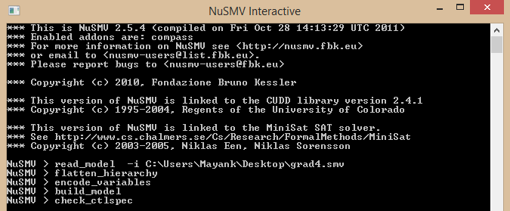

4.2 Result
The model checker takes a model and the properties to be verified as input, a counterexample will be generated when the property is discovered to be false. A counterexample is a sequence of states which start from initial page to the state that violates the property. In SMV, 1 and 0 denote true and false, “!, &, |” denotes “￢,^,∨”. We present in the Appendix section, the snapshots of the NuSMV execution results and tried to explain some of the FALSE properties i.e. counter ex.

5.0 Conclusion
This project report has described a methodology for modeling and verifying the Student Grade Web application design. The system model mainly focused on page navigation system in view of end user expectation.
In this project, we have represented a systematic way to express the model in NuSMV Interactive model checker tool. Besides, the Reachability, Liveness and Safety properties are represented in CTL formulas. Finally, NuSMV, model checking tools are used to verify those properties. The experimental results have shown that our developed model satisfied most the requirements thus generating the TRUE value except for few of them which could be demonstrated using the counter examples.

6.0 Future Work
Our model could be improvised accordingly as per the user mentioned specifications and automated regression suite of test cases could be developed further in order to ensure the quality and accuracy towards this web application system in the design phase of software development. The model could be designed using other model checking tools like PRISM (probabilistic model checker), SPIN and MACMASS in which the specified properties could be verified in order to acquire the knowledge over the efficiency of multiple model checker tools.

7.0 References
[1] Paul and Haque, “Modeling and Verifying e-shopping System”, Concordia University, Montreal, 2013
[2] D. Castelluccia et al., “A Model Checking-based Tool to Verify Web Application Design” in Electronic Notes in Theoretical Computer Science, Bari, Italy, 2009
[3] Edmund M. Clarke et al., “Model Checking and State Explosion Problem”, Carnegie Mellon University, Pittsburgh, 2011
[4] Marc Frappier et al., “Comparison of Model Checking tools for Information Systems”, GRIL, Université de Sherbrooke, Québec, Canada, June 16 2010
[5] Jamal Benthar. (2015, April 9), Model Checking and Binary Decisions Diagram [online]. Available:http://users.encs.concordia.ca/~benthar/INSE6250/Lectures/Lectures%208&9-2015.pdf
[6] NuSMV 2.1,User Manual Introduction [online]. Available: http://nusmv.fbk.eu/NuSMV/userman/v21/nusmv_1.html

8.0 Appendix

8.1 NuSMV Code
MODULE main
VAR
state: {s0, s1, s2, s3, s4, s5, s6, s7, s8, s9, s10, s11};

page-HomePage:boolean;
page-LoginPage: boolean;
page-LoginCheck: boolean;
page-News: boolean;
page-LoginFail: boolean;
page-StudentView: boolean;
page-Grade: boolean;
page-GetGrade: boolean;
page-GradeList: boolean;
page-StudentInfo: boolean;
page-GetStudent: boolean;
page-Exit: boolean;
link-News: boolean;
link-LoginPage: boolean;
link-Grade: boolean;
call-LoginCheck: boolean;
call-GetStudent: boolean;
call-GetGrade: boolean;
build-StudentView: boolean;
build-LoginFail: boolean;
build-GradeList: boolean;
build-StudentInfo: boolean;

ASSIGN
init(state):= s0;
init(page-HomePage):=TRUE;
init(page-LoginPage):=FALSE;
init(page-LoginCheck):=FALSE;
init(page-News):=FALSE;
init(page-LoginFail):=FALSE;
init(page-StudentView):=FALSE;
init(page-Grade):=FALSE;
init(page-GetGrade):=FALSE;
init(page-GradeList):=FALSE;
init(page-StudentInfo):=FALSE;
init(page-GetStudent):=FALSE;
init(page-Exit):=FALSE;
init(link-News):=TRUE;
init(link-LoginPage):=TRUE;
init(link-Grade):=FALSE;
init(call-LoginCheck):=FALSE;
init(call-GetStudent):=FALSE;
init(call-GetGrade):=FALSE;
init(build-StudentView):=FALSE;
init(build-LoginFail):=FALSE;
init(build-GradeList):=FALSE;
init(build-StudentInfo):=FALSE;

next(state):=case
state=s0: {s1,s2};
state=s1: s11;
state=s2: s3;
state=s3: {s4,s5};
state=s4: {s6,s9};
state=s5: s2;
state=s6: s7;
state=s7: s8;
state=s8: s11;
state=s9: s10;
state=s10: s6;
state=s11: s11;
TRUE: state;
esac;

next(page-HomePage):=case
next(state)=s0: TRUE;
TRUE:FALSE;
esac;
next(page-News):=case
next(state)=s1: TRUE;
TRUE:FALSE;
esac;
next(page-LoginPage):=case
next(state)=s2: TRUE;
TRUE:FALSE;
esac;
next(page-LoginCheck):=case
next(state)= s3:TRUE;
TRUE:FALSE;
esac;

next(page-LoginFail):=case
next(state)=s5:TRUE;
TRUE:FALSE;
esac;
next(page-StudentView):=case
next(state)=s4:TRUE;
TRUE:FALSE;
esac;
next(page-Grade):=case
next(state)=s6:TRUE;
TRUE:FALSE;
esac;
next(page-GetGrade):=case
next(state)=s7:TRUE;
TRUE:FALSE;
esac;
next(page-GradeList):=case
next(state)=s8:TRUE;
TRUE:FALSE;
esac;
next(page-StudentInfo):=case
next(state)=s10:TRUE;
TRUE:FALSE;
esac;
next(page-GetStudent):=case
next(state)=s9:TRUE;
TRUE:FALSE;
esac;
next(page-Exit):=case
next(state)=s11:TRUE;
TRUE:FALSE;
esac;
next(link-News):=case
next(state)=s0: TRUE;
TRUE: FALSE;
esac;
next(link-LoginPage):=case
next(state)=s0: TRUE;
TRUE: FALSE;
esac;
next(link-Grade):=case
next(state)=s4|next(state)=s10: TRUE;
TRUE: FALSE;
esac;
next(call-LoginCheck):=case
next(state)=s2: TRUE;
TRUE: FALSE;
esac;
next(call-GetStudent):=case
next(state)=s4: TRUE;
TRUE: FALSE;
esac;
next(call-GetGrade):=case
next(state)=s6: TRUE;
TRUE: FALSE;
esac;
next(build-StudentView):=case
next(state)=s3: TRUE;
TRUE: FALSE;
esac;
next(build-LoginFail):=case
next(state)=s3: TRUE;
TRUE: FALSE;
esac;
next(build-GradeList):=case
next(state)=s7: TRUE;
TRUE: FALSE;
esac;
next(build-StudentInfo):=case
next(state)=s9: TRUE;
TRUE: FALSE;
esac;

8.2 Counter Examples
- (Reachability): SPEC AG (page-LoginCheck -> AX page-StudentView): All the paths leading from page-LoginCheck do not always end up in next page as Student view
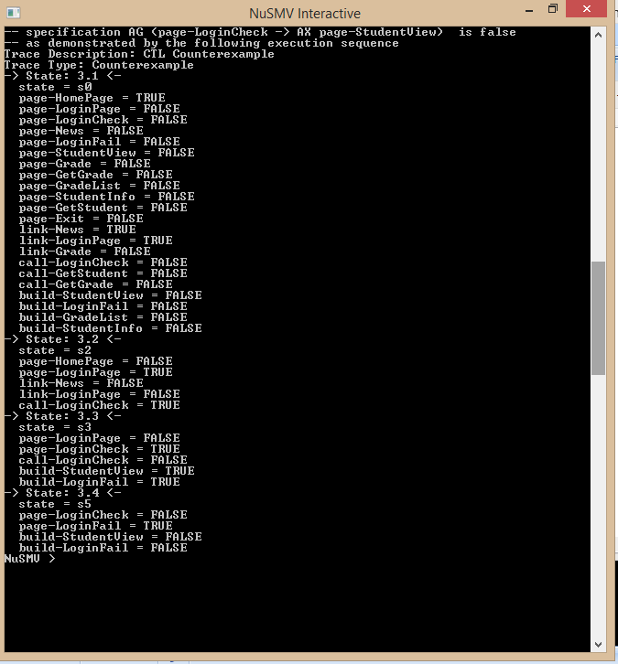
- (Safety): SPEC AG(page-LoginFail -> EX page-Exit): If user ends up in login failed page then next page should not be exit page rather is should go back to login page thus we get a counter example thus a safety feature of our model for the specification.
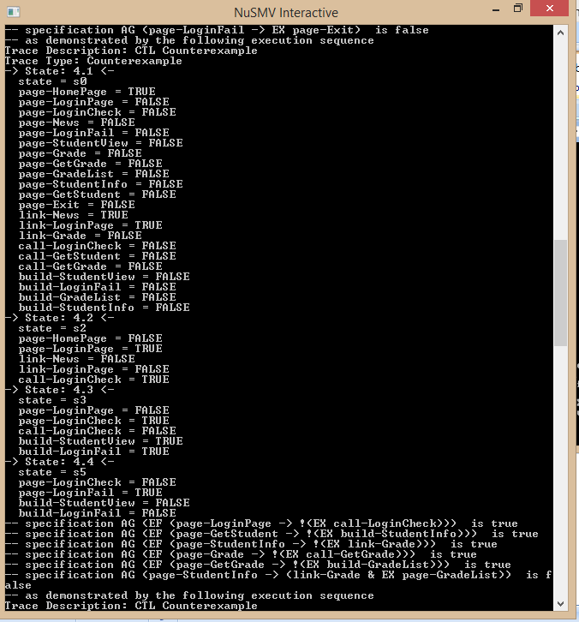

- (Reachability): SPEC AG (page-StudentView -> AX page-Grade): Since there are 2 paths from student view thus all the paths from student view will not always end up in next state as grade page
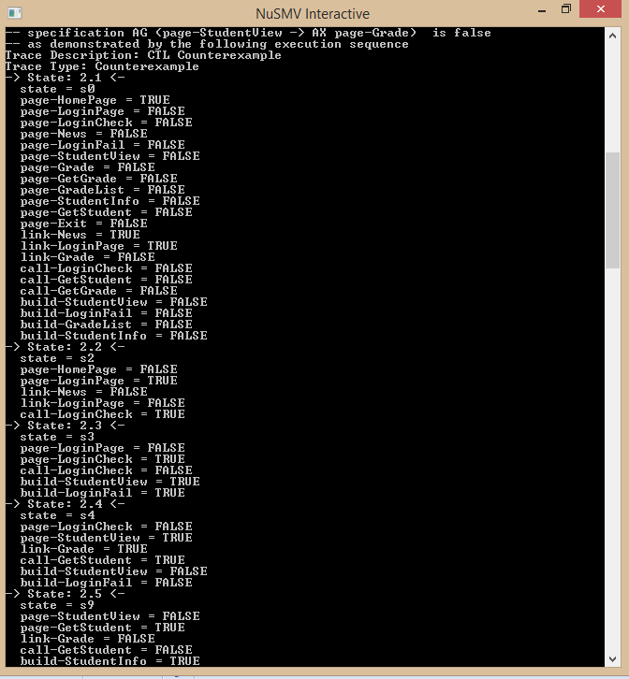
- (Liveness): SPEC AG(page-StudentView -> (link-Grade & EX page-GradeList)): If user is on student view and clicks on grade link then it should show list of grades but this is not true as per our model hence counter example

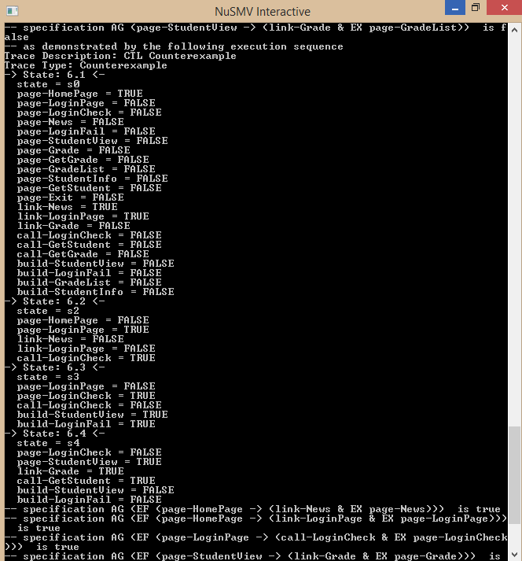
- (Reachability): SPEC AG (page-HomePage -> AX page-LoginPage): Since there are 2 paths from home page in our model and all these paths from home page will not always end up in next state as login page

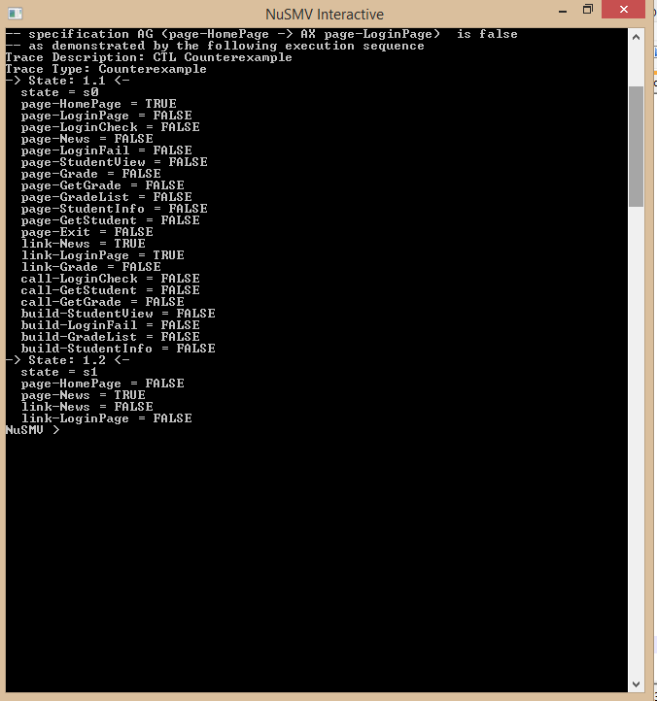
- (Liveness): SPEC AG(page-StudentInfo -> (link-Grade & EX page-GradeList)): If user is on student info page and clicks link of grade then it should give grade list but as per our model user is prompted to enter some values as explained in model above which will give him a grade list page from get grade page.
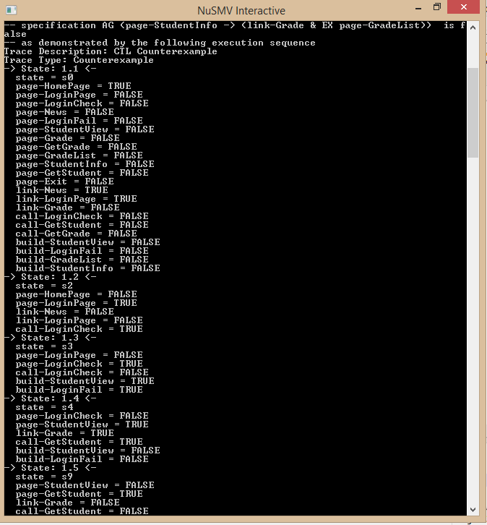
Rest all the properties are TRUE as verified by NuSMV Model checker tool.

